# Original Paragraph

**Determining how the username and password are encrypted**

Download the APK from somewhere like APKPure (or use adb to pull it off your phone) and decompile it using [Apktool](https://ibotpeaches.github.io/Apktool/). In the resulting directory, we need to find the method that performs the login, as this will give us a place to work back from. Searching for the endpoint is usually a good start:

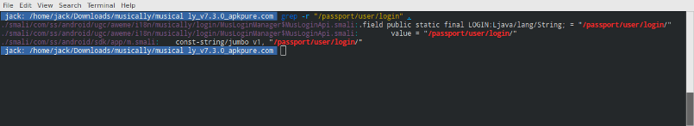

Searching for references to the login endpoint

The first two results look somewhat promising; it looks like the constant used to identify the endpoint is **LOGIN**. However, searching for its usages using ;->LOGINreturns no interesting results. Turn your attention to the third result — where the first two were under an internationalisation directory (i18n), this file is under **app**.

# Revised Paragraph

**Determining Username and Password Encryption Type**

Download the APK from an APK downloader, such as APKPure (or use adb to pull it off your phone). Then, compile it using [Apktool](https://ibotpeaches.github.io/Apktool/). In the resulting directory, we need to find the login method to provide a place to work back from. Start by searching for the endpoint:



Searching for references to the login endpoint

The first two results look somewhat promising; it looks like the constant used to identify the endpoint is **LOGIN**. However, searching for its usages using ;->LOGINdoes not return useful results. The third result’s file is under **app**, while the first two are under an internationalization directory (i18n).